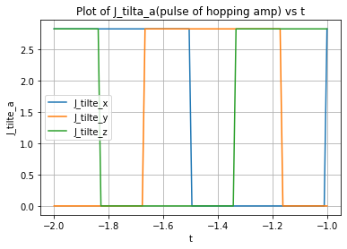
Graph of J_a when periodic, t <0
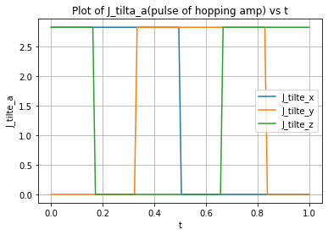
Graph of J_a when not periodic, pulse only turns on within period T (0 to 1)

(-1.7313036243496107e-15-2.827433388230814j)
【 Rho_edge_Phi_eigvec_n 】 is the var contain adjustion of () states
orNxNy_OBC_vor_fig4a.py')
(6.650690332514586e-18-6.472373694023417e-18j)
(6.650690332514586e-18-6.472373694023417e-18j)
(6.650690332514586e-18-6.472373694023417e-18j)
(6.650690332514586e-18-6.472373694023417e-18j)
(6.650690332514586e-18-6.472373694023417e-18j)
(6.650690332514586e-18-6.472373694023417e-18j)
(6.650690332514586e-18-6.472373694023417e-18j)
(6.6471435196742505e-18-6.468119834939062e-18j)
(5.539286266395209e-18-5.4251688249959975e-18j)
(5.539286266395209e-18-5.4251688249959975e-18j)
(5.5369209679420525e-18-5.422592708657222e-18j)
(5.533967370818785e-18-5.419368553519674e-18j)
(5.533967181693286e-18-5.419368523094962e-18j)
(5.533967181693286e-18-5.419368523094962e-18j)
(5.533967181693286e-18-5.419368523094962e-18j)
(5.539879576984655e-18-5.4260827593926135e-18j)
(5.5372201287608425e-18-5.42261109190787e-18j)
(-5.024179170867785e-21-5.868349852666873e-20j)
(2.9570959161964614e-22-6.532194724406144e-20j)
(2.957095916196465e-22-6.532194724406144e-20j)
(5.913246132893512e-22-6.337238407234186e-20j)
(5.912300145408041e-22-6.33725251559822e-20j)
(5.9123005773998765e-22-6.337252519802327e-20j)
(5.912300577399874e-22-6.337252519802327e-20j)

(6.650690332514586e-18-6.472373694023417e-18j)
(6.650690332514586e-18-6.472373694023417e-18j)
(6.650690332514586e-18-6.472373694023417e-18j)
(6.650690332514586e-18-6.472373694023417e-18j)
(6.650690332514586e-18-6.472373694023417e-18j)
(6.650690332514586e-18-6.472373694023417e-18j)
(6.650690332514586e-18-6.472373694023417e-18j)
(6.6471435196742505e-18-6.468119834939062e-18j)
(5.539286266395209e-18-5.4251688249959975e-18j)
(5.539286266395209e-18-5.4251688249959975e-18j)
(5.5369209679420525e-18-5.422592708657222e-18j)
(5.533967370818785e-18-5.419368553519674e-18j)
(5.533967181693286e-18-5.419368523094962e-18j)
(5.533967181693286e-18-5.419368523094962e-18j)
(5.533967181693286e-18-5.419368523094962e-18j)
(5.539879576984655e-18-5.4260827593926135e-18j)
(5.5372201287608425e-18-5.42261109190787e-18j)
(-5.024179170867785e-21-5.868349852666873e-20j)
(2.9570959161964614e-22-6.532194724406144e-20j)
(2.957095916196465e-22-6.532194724406144e-20j)
(5.913246132893512e-22-6.337238407234186e-20j)
(5.912300145408041e-22-6.33725251559822e-20j)
(5.9123005773998765e-22-6.337252519802327e-20j)
(5.912300577399874e-22-6.337252519802327e-20j)
(5.912300505392172e-22-6.337252520351257e-20j)
(-2.955677546958547e-22-1.2377550509162434e-18j)
(-2.955677546958547e-22-1.2377550509162434e-18j)
(-2.9556774029479457e-22-1.237755041323274e-18j)
(-2.9556774029479457e-22-1.2376950509548958e-18j)
(-2.9537865079853676e-22-1.2370343192100938e-18j)
(-2.953786507985368e-22-1.2370343192100938e-18j)
(1.5163951729722817e-36-1.2372691752542497e-18j)
(1.0231571750435062e-36-1.238992639494233e-18j)
(2.2110136463882734e-36-3.4578191249471462e-18j)
(1.1826492409796032e-21-3.4567672092232396e-18j)
(1.182649240979604e-21-3.4567672092232396e-18j)
(1.1826492409796038e-21-3.4567672092232396e-18j)
(1.1826492409796038e-21-3.4567672092232396e-18j)
(1.1826492409796038e-21-3.4567672092232396e-18j)
(1.1826492409796038e-21-3.4567672092232396e-18j)
(-6.503530714337765e-21-3.447312455716981e-18j)
(1.1828384096825728e-21-3.456188000467534e-18j)
(8.873505084577873e-18-6.5389981771681505e-18j)
(-3.0118831602065844e-05-6.510639306299404e-18j)
(-3.011883160206584e-05-6.510639306305866e-18j)
(-3.01236477428609e-05-6.5225699666067455e-18j)
(-3.01236477428609e-05-6.5225699666067455e-18j)
(-3.01236477428609e-05-6.5225699666067455e-18j)
(-3.0123647742860908e-05-6.5215174120564684e-18j)
(-3.0123647742860908e-05-6.5215174120564684e-18j)

For double chek:
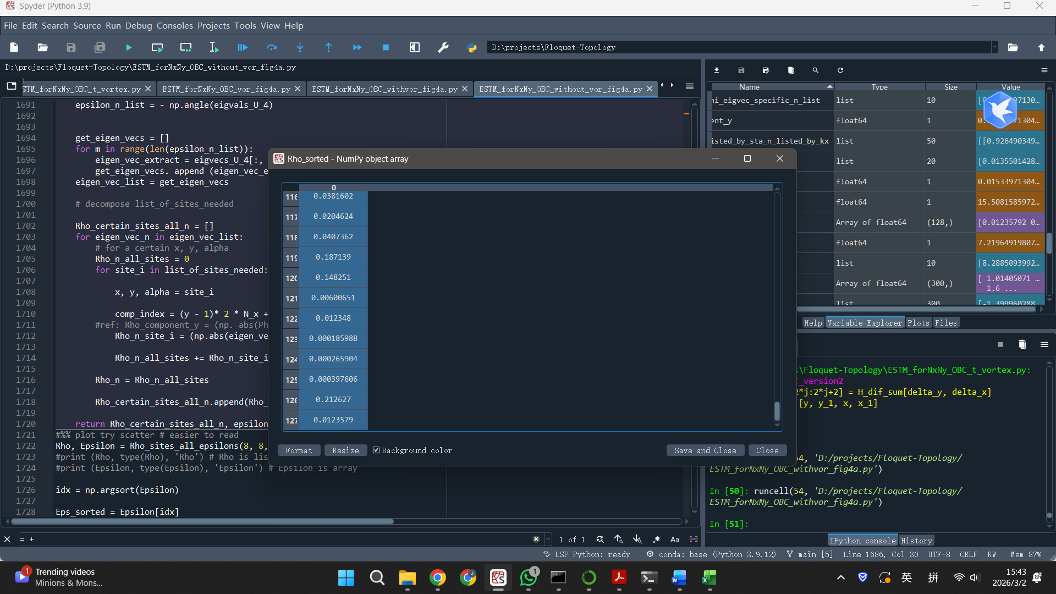
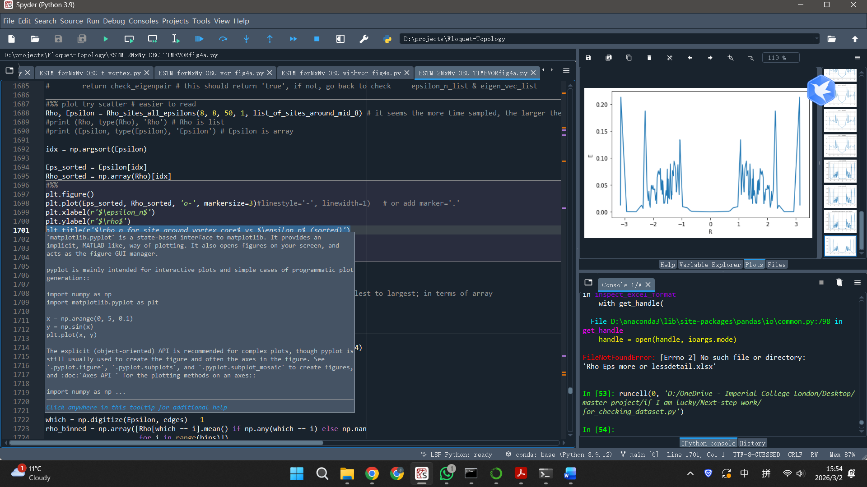
This is the final version of code

New version of final code

3.3 Afternoon
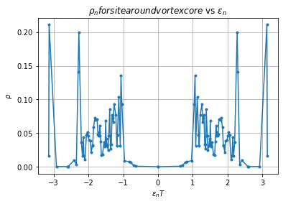
T discretisation 60

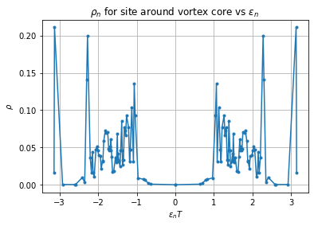
T discretisation 60(maybe overrun a bit of data)

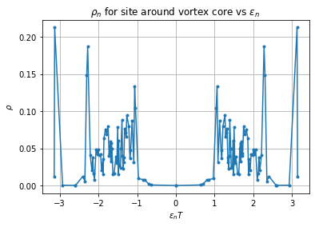
T discretisation 50

peak (3.1270024120555564, 0.211094990100902) – which is even smaller than the case with smaller time discretisation (T= 50)??
peak for Rho difference (3.1270024120555564, 0.21100758259915325)
Q: why by abstracting Rho_no_vor, the peak doesn’t move a bit?
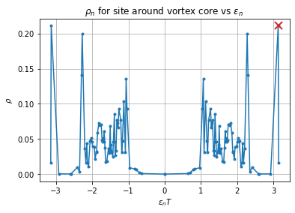
Peak identified for ‘with time vortex’ T_dis = 60
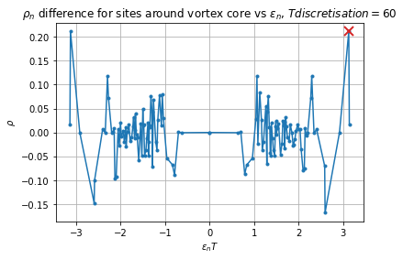
Peak identified for ‘no vor’ T_dis = 60

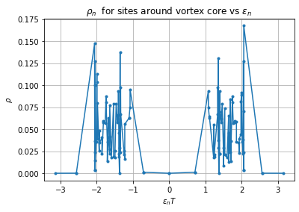
No vortex T dis = 60 (You can see this is not symmetrical and the bulk Rho are messy and floating between(left higher, right lower, or inverse)

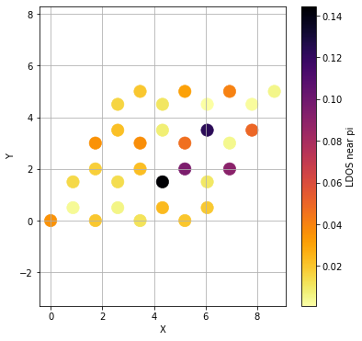
4x4 time stages 35 pi offset: 0.12 mid_vor_core: Nx+1/2, Ny+1/2 (maybe here is some problems?)

# YOU CAN ALSO TRY SUMMED OVER THE SITES FOR EACH UNIT CELLS ! BECAUSE IT MIGHT NOT NECESSARILY TO BE SAME FOR 'SITE LOCALISATION' AND 'CELL LOCALISATION'
# TRY ADJUST TIME VORTEX CORE’S LOCATION: CORNER: (X=1, Y=1, ALPHA1 OR 1&&2); AT CERTAIN SITE / CELL: (X=4, Y=4, INSTEAD OF 4.5, 4.5,…)

